**FUNCTIONAL AND TECHNICAL COMBINED DOCUMENTATION**

**Page (61): MonitorFI (Front End Url:** http://localhost:8100/page61/Page61)

**Functional Picture:**

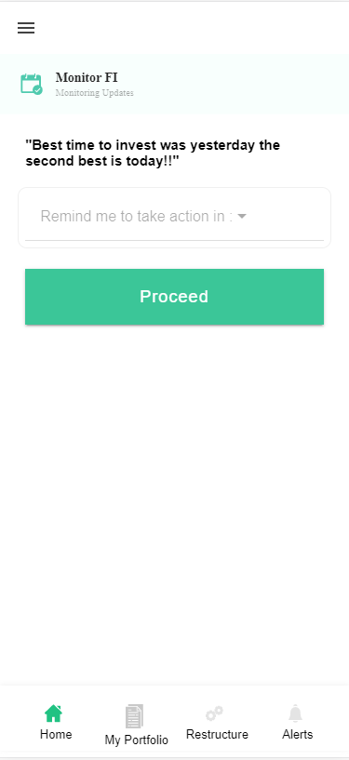

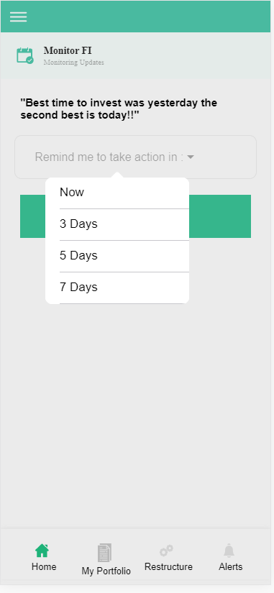

**Technical Explanation (Front End and Back End):**

**In Page61.tsx, we are calling following 3 APIs:**

1. **DoItLaterAPIFI**: see backend python file
2. **AddToWatchListAPIFI**: see backend python file
3. **OnlyForWatchListAPIFI**: see backend python file

**In this Page, the user will choose to invest the EasyVest recommended stocks if he selects the option “Now” and he will be directly redirected to “Trade Register for Fixed Income”. Other than “Now” option, if he chose other options like “3days”, “5days” and “7days”, then it will get saved in his “Reminder(DoItLaterFI)” database and he will be redirected to “MyPortfolio”.**

**’**

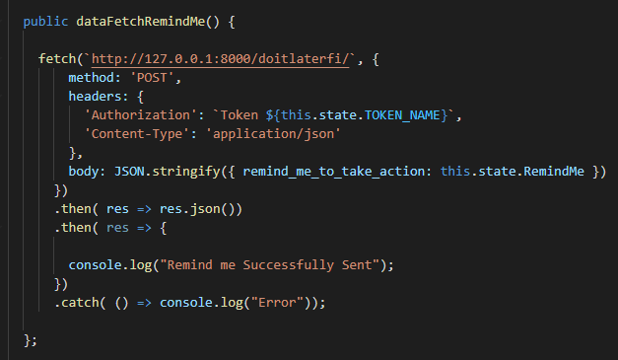

**As you can see, we are calling the DoItLaterAPIFI using this url:** [**http://127.0.0.1:8000/doitlaterfi/**](http://127.0.0.1:8000/doitlaterfi/)**.**

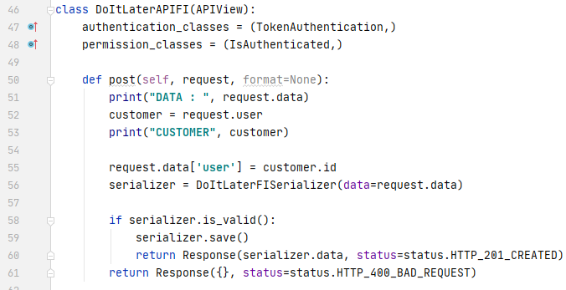

**The Above API is saving the reminder input that was given by the user in the DoItLaterFI model database using DoItLaterFISerializer. Please see the code of DoItLaterFI database and DoItLaterFISerializer given below.**

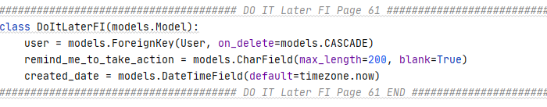

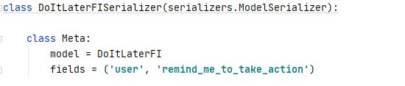

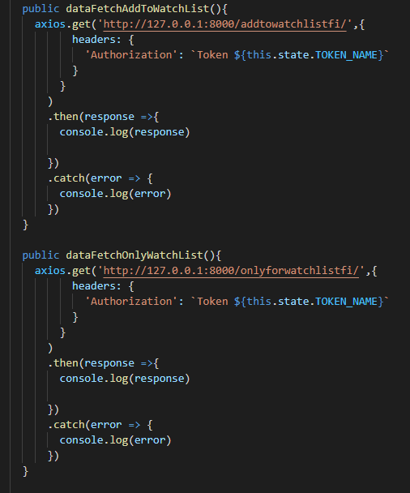

**In the above given code, which will call two API’s named** AddToWatchListAPIFI **and** OnlyForWatchListAPIFI. These two will get trigger if the user have chosen 3day, 5day and 7days because till that time the portfolio recommendation will get saved to our MyHoldingOrWatchlistFI

and WatchlistFI database.

Please refer to the below code.

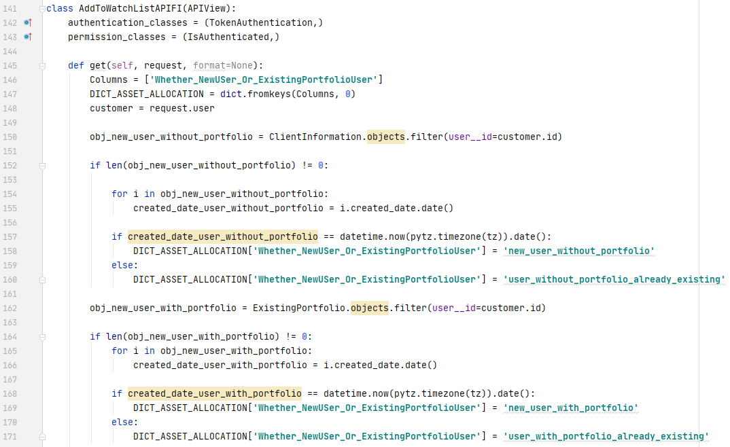

**From Line Number 150 to 171, we are checking the type of the user who do not have his own fixed Income portfolio using the ClientInformation database model.**

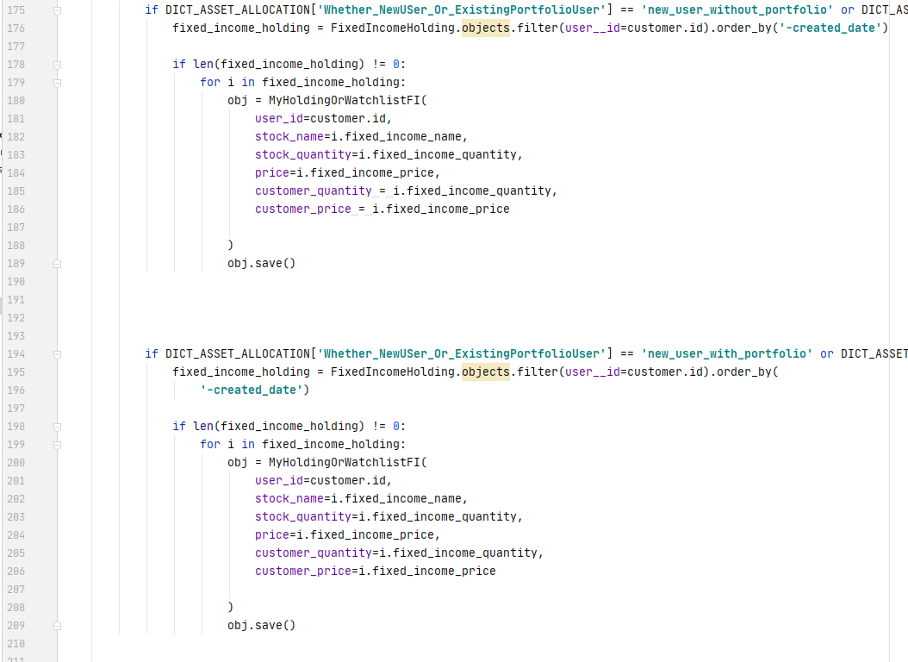

**Please Look on Line Number 175 to 188. If the user is either “new_user_without_portfolio” or “user_without_portfolio_already_existing”, then we are copying the FixedIncomeHolding model database portfolio into MyHoldingOrWatchListFI model database.**

**Now Please Look on Line Number 198 to 208. If the user is either “new_user_with_portfolio” or “user_with_portfolio_already_existing”, then we are copying the FixedIncomeHolding model database portfolio into MyHoldingOrWatchListFI model database.**

**DONE!!!**